Course: ITECH3102: Big Data and Data Visualisation
Assessment: Task 4 - Interactive Dashboard Implementation & Analysis Report
Student Name: ClientX
Student ID: STUDENTIDX
Institution: Federation University Australia
Submission Date: 18 October 2026

Assessment Task 4: Capstone Project

This document presents my implementation of the interactive dashboard and the accompanying analysis report. I have used Tableau to create four linked worksheets based on the Massachusetts high school performance dataset. The report answers five analytical questions with screenshots, explains my design choices, and reflects on the lessons learned during implementation.

Analysis Report: Massachusetts High School Performance Dashboard
Executive Summary
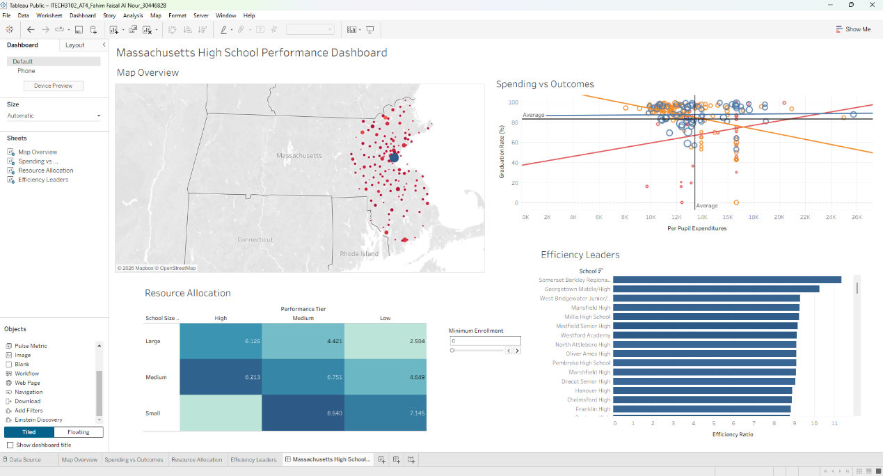
This interactive dashboard analyzes Massachusetts high school performance data to uncover structural relationships between educational funding, institutional resources, school scale, and student outcomes. Implemented in Tableau Public, the core dashboard integrates four linked views: a geographic Map Overview, a Spending vs Outcomes scatter plot, a Resource Allocation heat map, and an Efficiency Leaders horizontal bar chart, supplemented by a fifth analytical worksheet examining College Readiness across resource bins. Together, these visualizations address five multi-variable analytical questions regarding educational equity and resource effectiveness across Massachusetts. Key findings demonstrate that while per-pupil expenditure exhibits a positive baseline relationship with graduation outcomes, substantial variance persists across school size tiers. Several medium and large regional schools achieve graduation rates above 90% with moderate per-pupil spending between $10,000 and $14,000, whereas certain higher-spending urban institutions continue to face systemic graduation challenges. Furthermore, per-student resource indices and college attendance rates reveal that targeted resource allocation and school scale management are more decisive drivers of student success than raw expenditure totals alone.

Question 1: Does higher per-pupil expenditure correlate with better graduation rates?
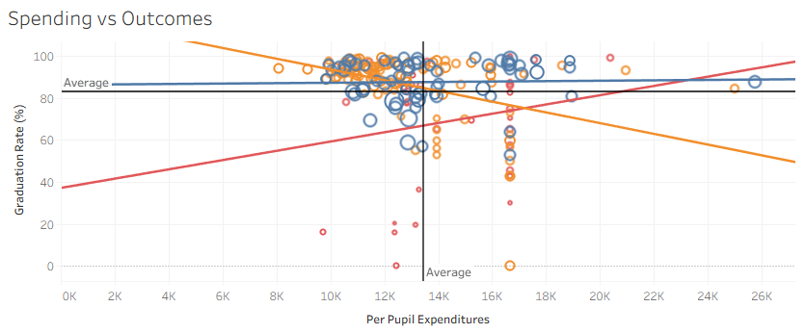
Visual Encoding: Per-pupil expenditure (Per Pupil Expenditures) is mapped to the horizontal x-axis (continuous, quantitative), while the four-year graduation rate (Graduation Rate (%)) is mapped to the vertical y-axis (continuous, quantitative). Circle size encodes total student enrollment (quantitative), and mark color distinguishes school size categories (blue for Large, orange for Medium, and red for Small), accompanied by category-specific linear trend lines and black vertical and horizontal reference lines marking the statewide averages.
Analysis: The scatter plot reveals that the relationship between per-pupil spending and graduation rates is strongly moderated by school size. Across the dataset, the average per-pupil expenditure sits just above $13,400 with an average graduation rate near 83%. Most Large (blue) and Medium (orange) schools cluster tightly in the upper-middle quadrant, achieving graduation rates between 85% and 99% at expenditure levels between $10,000 and $16,000. The blue trend line for large schools remains nearly flat and high across the spending spectrum, indicating stable graduation performance regardless of marginal funding increases. Conversely, Small schools (red circles) display a steep upward red trend line alongside extreme vertical dispersion, with several low-enrollment institutions recording graduation rates below 40% despite spending $12,000 to $16,700 per pupil. Meanwhile, the orange trend line for medium-sized schools slopes downward slightly due to a vertical cluster of specialized schools near the $16,700 mark with lower graduation rates. This confirms that higher expenditure alone does not guarantee superior graduation outcomes.

Question 2: How do MCAS performance and SAT scores vary geographically?
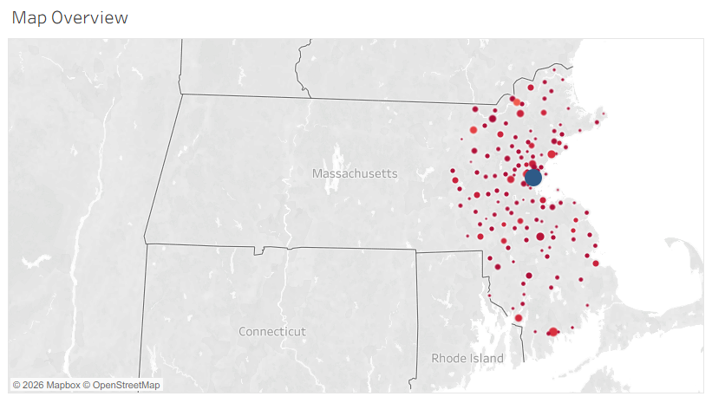
Visual Encoding: Geographic position is encoded using city-level latitude and longitude coordinates across Massachusetts. Circle size represents aggregate student enrollment (quantitative), while mark color uses a diverging red-to-blue color scale to reflect academic achievement and SAT/MCAS performance levels across municipalities, supported by interactive tooltips for school-level inspection.
Analysis: The proportional symbol map highlights pronounced geographic concentration across eastern and central Massachusetts, where population density and school networks are highest. A prominent dark-blue circular marker in the Greater Boston metropolitan core reflects the massive aggregate student enrollment and concentrated institutional capacity of the state's primary urban center, surrounded by a dense ring of suburban high schools across Middlesex, Norfolk, and Essex counties. Moving outward toward southeastern Massachusetts, Bristol County, and the Worcester corridor, markers appear in varying shades of red and orange with smaller radii, reflecting smaller district enrollments and wider disparities in standardized assessment outcomes. Coastal and regional communities in the northeast and southeast exhibit noticeable clusters of red markers, indicating localized achievement gaps that align with regional socioeconomic variations. By combining spatial positioning with size and color channels, the map allows policy analysts to immediately pinpoint regional clusters requiring targeted academic intervention.

Question 3: How do school resources vary across different school sizes and performance tiers?
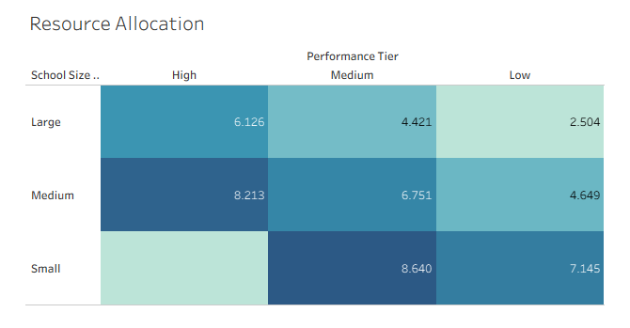
Visual Encoding: Rows represent the derived School Size category (categorical: Large, Medium, Small), while columns represent the ordered Performance Tier (ordinal: High, Medium, Low). Both cell color saturation (sequential teal-blue palette) and embedded text labels encode the average derived Resource Index (quantitative).
Analysis: The heat map demonstrates that per-student resource availability varies systematically across both institutional scale and academic performance tiers. Small schools in the Medium performance tier record the highest average resource index across the entire state at 8.640, closely followed by Medium-sized schools in the High performance tier at 8.213. Notably, the bottom-left cell (Small size and High performance tier) is empty, indicating that no small high schools in the dataset fall into the top composite performance tier, even though small schools in the Low tier still maintain a substantial resource index of 7.145. In contrast, Large high schools consistently exhibit lower per-student resource indices across every performance bracket, declining from 6.126 in the High tier to 4.421 in the Medium tier, and reaching a statewide minimum of 2.504 in the Low performance tier. This gradient confirms that smaller and medium-sized institutions maintain higher per-student resource intensity, whereas large low-performing schools suffer from severe resource dilution.

Question 4: How do school resources relate to college readiness?
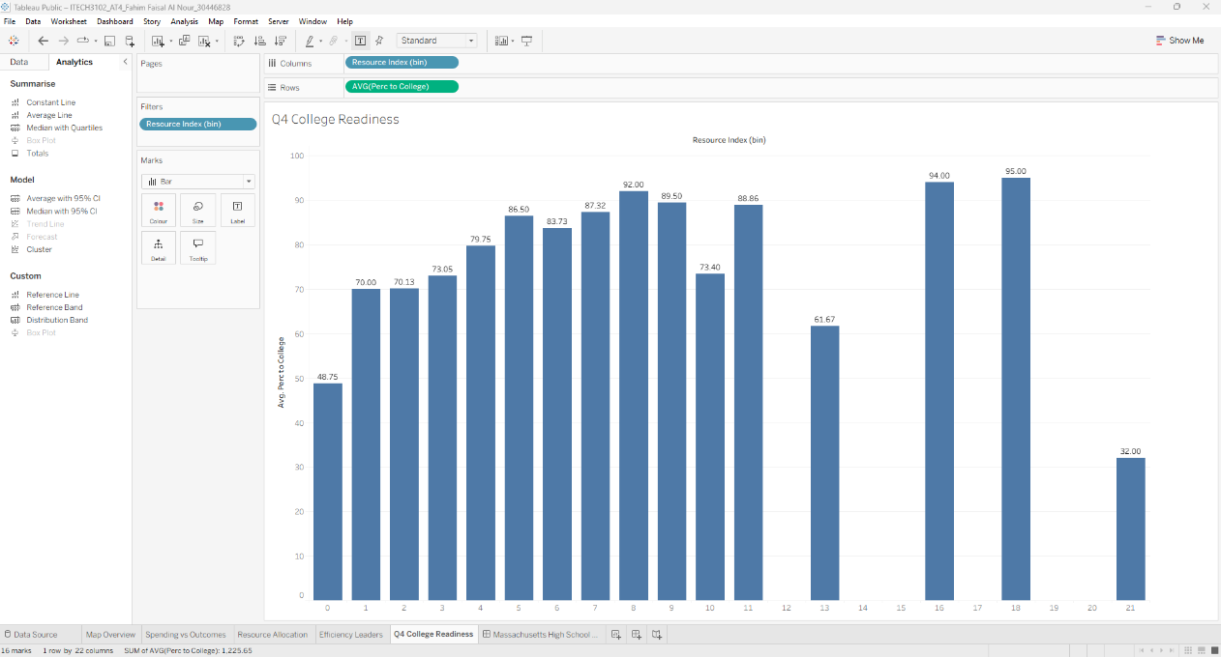
Visual Encoding: Derived Resource Index (bin) intervals ranging from 0 to 21 are ordered sequentially along the horizontal x-axis (ordinal), while the vertical y-axis encodes the average percentage of graduates attending college (AVG(Perc to College), quantitative) using vertical bar height and exact numerical data labels at the top of each bar.
Analysis: The binned bar chart illustrates a clear positive progression between per-student resource availability and college readiness across almost the entire distribution. Schools in the lowest resource bracket (bin 0) record a modest average college attendance rate of 48.75%. As the resource index increases to bin 1 and bin 2, average college attendance jumps sharply to 70.00% and 70.13%, before climbing steadily through bins 4 to 8, where attendance reaches 92.00%. Although minor fluctuations occur in bins 10 (73.40%) and 13 (61.67%), the highest college attendance rates in Massachusetts are achieved in the upper resource tiers, peaking at 94.00% in bin 16 and 95.00% in bin 18. An intriguing outlier appears at the extreme right of the distribution in bin 21, where college attendance drops to 32.00%; this bin captures specialized resource-intensive vocational or alternative institutions where graduates predominantly transition directly into technical careers rather than four-year colleges.

Question 5: Which schools achieve high outcomes with lower expenditures?
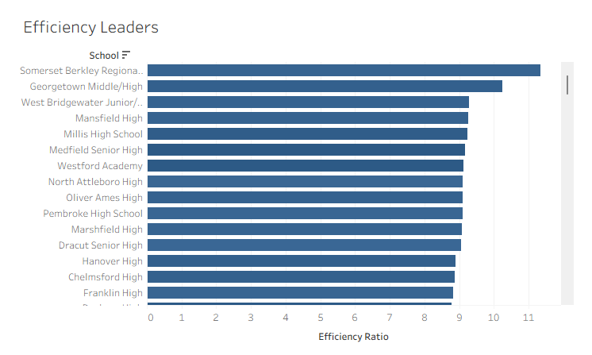
Visual Encoding: Individual high schools (School) are arranged along the vertical y-axis (nominal, sorted in descending order of efficiency), while horizontal bar length along the x-axis encodes the calculated Efficiency Ratio (quantitative), which measures composite student achievement relative to per-pupil expenditure.
Analysis: The horizontal bar chart ranks the top-performing Massachusetts high schools that generate the highest educational return per dollar spent. Somerset Berkley Regional stands out as the statewide efficiency leader with an Efficiency Ratio exceeding 11.3, followed by Georgetown Middle/High in second place with a ratio above 10.2. Directly below the top two leaders, a highly competitive group of suburban and regional high schools clusters tightly with efficiency ratios between 9.0 and 9.3, led by West Bridgewater Junior/Senior, Mansfield High, Millis High School, Medfield Senior High, Westford Academy, North Attleboro High, and Oliver Ames High. Rounding out the visible top tier are Pembroke High School, Marshfield High, Dracut Senior High, Hanover High, Chelmsford High, and Franklin High, all maintaining ratios just below 9.0. These institutions exemplify disciplined fiscal management, proving that schools do not need to be in the highest spending brackets ($20,000+) to deliver exceptional graduation and academic outcomes.

Visual Encoding Choices and Rationale
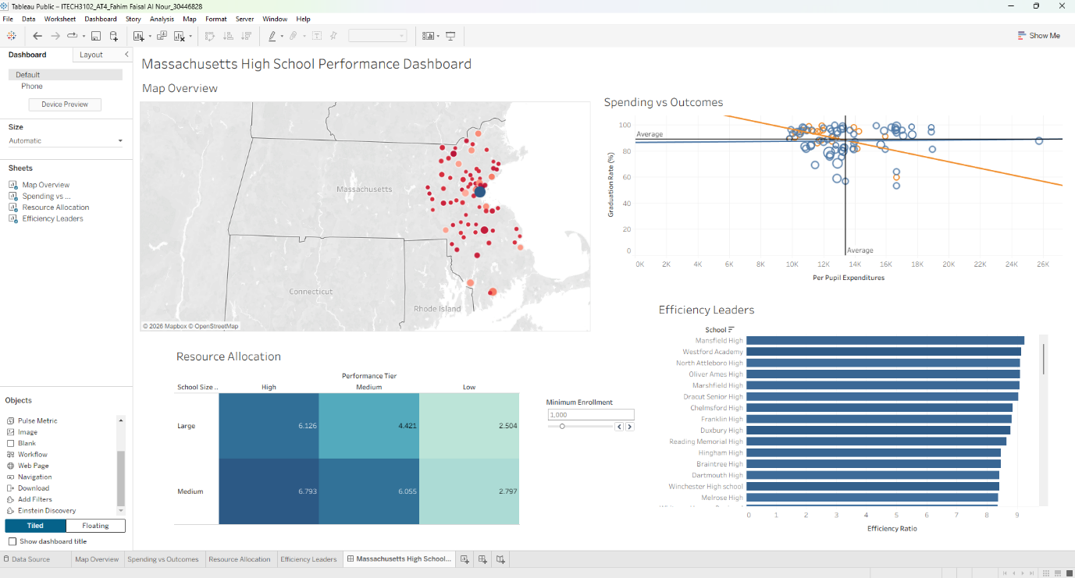
The visual encodings across the dashboard were designed in alignment with Munzner's (2014) effectiveness rankings and Few's (2012) dashboard design principles. Planar spatial position, the most accurate human perceptual channel, was reserved for the primary analytical comparisons: Per Pupil Expenditures versus Graduation Rate in the scatter plot, and Efficiency Ratio rankings in the horizontal bar chart. Calculated fields were engineered to transform raw school metrics into meaningful analytical abstractions, including the Efficiency Ratio (normalizing outcome scores against per-pupil spending), Resource Index (synthesizing staffing and resource availability), and categorical binning for School Size and Performance Tier. Hue and saturation were applied purposefully: categorical colors differentiate school size tiers in the scatter plot through preattentive processing, while a sequential teal-blue ramp in the heat map intuitively maps higher numerical density to darker shading. Circle area in the scatter plot and map encodes student enrollment magnitude. Finally, interactive filter actions and the Minimum Enrollment control empower users to dynamically slice the dataset and compare structural shifts across all panels simultaneously.

Usage Scenario
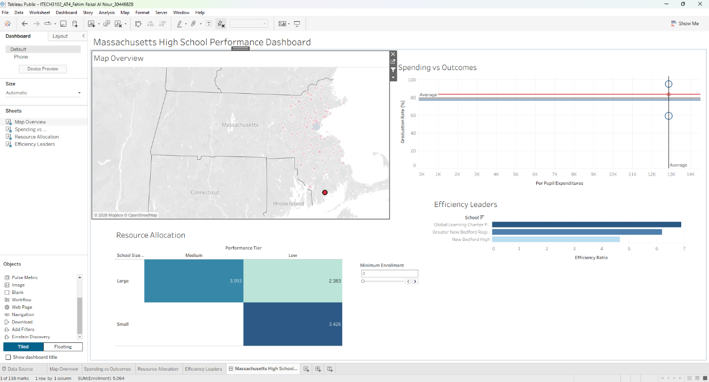
A state education policy analyst launches the dashboard to investigate regional performance disparities and identify benchmark schools. Beginning with the initial overview (Minimum Enrollment set to 0), she scans the Map Overview and notices a distinct cluster of red markers along the southeastern coast of Massachusetts. In Step 1, she clicks directly on the New Bedford coastal mark on the map, triggering a cross-worksheet filter action across the entire dashboard (as illustrated in the screenshot above). The Spending vs Outcomes scatter plot immediately isolates the local schools near the $13,000 expenditure line, revealing a wide vertical gap in graduation rates from roughly 60% to 95%. Simultaneously, the Resource Allocation heat map updates to show only the Large (indices of 3.093 in Medium and 2.383 in Low) and Small (3.426 in Low) categories present in that cluster, while the Efficiency Leaders chart narrows to compare Global Learning Charter Public, Greater New Bedford Regional, and New Bedford High side by side. In Step 2, seeking peer benchmarks among larger institutions statewide, she clears the map selection and adjusts the Minimum Enrollment control to 1,000. The dashboard dynamically filters out all Small schools, updating the heat map to compare only Large and Medium tiers and elevating Mansfield High and Westford Academy to the top of the Efficiency Leaders ranking.

Reflection and Changes from Plan
Transitioning from the initial design proposal to the final Tableau implementation yielded several important design lessons and structural refinements. First, while the original proposal envisioned a parallel coordinates plot to compare multivariate resource metrics, early prototyping revealed severe line occlusion across 300+ schools; replacing that concept with the two-dimensional Resource Allocation heat map (Question 3) and the binned Q4 College Readiness bar chart (Question 4) vastly improved readability. Second, preparing the spatial data required assigning explicit city-level geographic roles in Tableau and filtering out unrecognized or incomplete records so that warning badges (nulls and unknown locations) did not clutter the final interface. A major strength of the final dashboard is its cohesive visual hierarchy and synchronized cross-filtering, which follows Shneiderman's (1996) visual information-seeking mantra. However, certain limitations remain: the dataset lacks longitudinal multi-year tracking, meaning the dashboard captures a single cross-sectional snapshot rather than multi-year trajectories, and aggregate city-level geocoding can cause overlapping markers in multi-school municipalities.

Conclusions and Recommendations
The visual analysis confirms that high school achievement in Massachusetts is shaped by a complex interplay of per-student resource intensity, institutional scale, and geographic context rather than gross expenditure alone. Four actionable policy recommendations emerge from these findings:
- Rebalance Resource Allocation Formulas: Shift state aid formulas from raw funding totals toward per-student resource availability, addressing the severe resource dilution observed in large, low-performing high schools (Resource Index of 2.504).
- Benchmark High-Efficiency District Models: Audit and replicate the instructional and administrative practices of top efficiency leaders such as Somerset Berkley Regional, Georgetown Middle/High, and Mansfield High across lower-performing districts.
- Target Regional Intervention Grants: Direct supplemental academic support to underperforming clusters identified in southeastern Massachusetts and urban centers where high expenditures have not translated into proportional graduation gains.
- Account for Institutional Scale: Differentiate policy targets for small specialized or vocational schools versus large comprehensive high schools.

Background Research
This project applied foundational frameworks from information visualization literature. Shneiderman's (1996) mantra ("overview first, zoom and filter, then details-on-demand") guided the interactive architecture linking the overview map and scatter plot to the drill-down filter actions. Munzner's (2014) nested model of visualization design and channel effectiveness rankings informed the selection of spatial position for quantitative comparisons, sequential saturation for heat map density, and categorical hue for school size segmentation. Finally, Few's (2012) dashboard design principles governed the single-screen four-panel layout, eliminating non-data ink and ensuring immediate visual clarity.
References
- Few, S. (2012). Show Me the Numbers: Designing Tables and Graphs to Enlighten. Analytics Press.
- Munzner, T. (2014). Visualization Analysis and Design. CRC Press.
- Shneiderman, B. (1996). The Eyes Have It: A Task by Data Type Taxonomy for Information Visualizations. Proceedings of the IEEE Symposium on Visual Languages, 336-343.
- Tableau Software. (2024). Tableau Help Documentation. Retrieved from https://help.tableau.com

